KIET Group of Institutions,Ghaziabad
Department of Computer Science

- Our student Saumya Choudhary from the batch 2023-2027.
Saumya competed in the 23rd Rajasthan State Rifle & Pistol Championship 2025, securing 26th rank in the 10m Air Pistol Junior Women category. Her performance earned her qualification for the 44th North Zone Shooting Championship, marking significant progress in her sporting career. 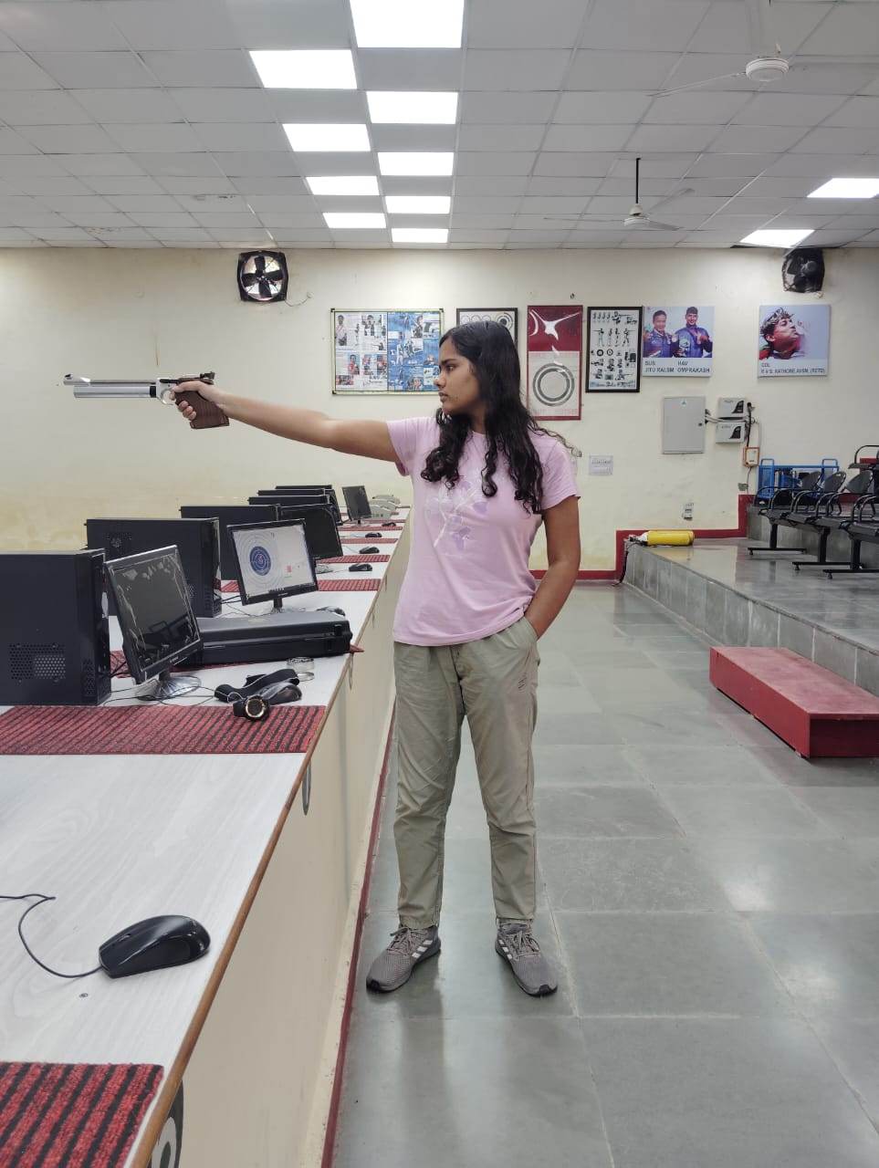

One of our student Shruti (Batch 2021-25) participated in the NASA Human Exploration Rover Challenge (HERC),where students from around the world take on an engineering challenge related to exploring space. Shruti Jain won the social media award at the 2023 HERC event in Alabama, USA, for her outstanding contribution amidst a lot of creative and talented participants.
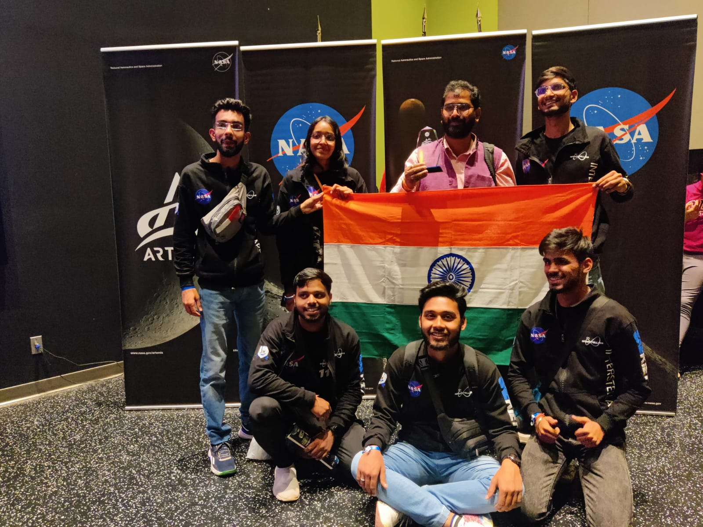

- Aryan Kaushik (Batch: 2021-2025) is a sophomore pursuing Bachelor's in Technology with a major in Computer Science. He was a former GSoC’22 Intern Under GNOME Foundation, where he worked on the Pitivi project and is selected for GSoC’23 Chromium. He has been elected as:
- Founder and Lead at GNOME Users Group Delhi - NCR
- Member of GNOME Internship Committee,
- Board Member @ LBRY Foundation
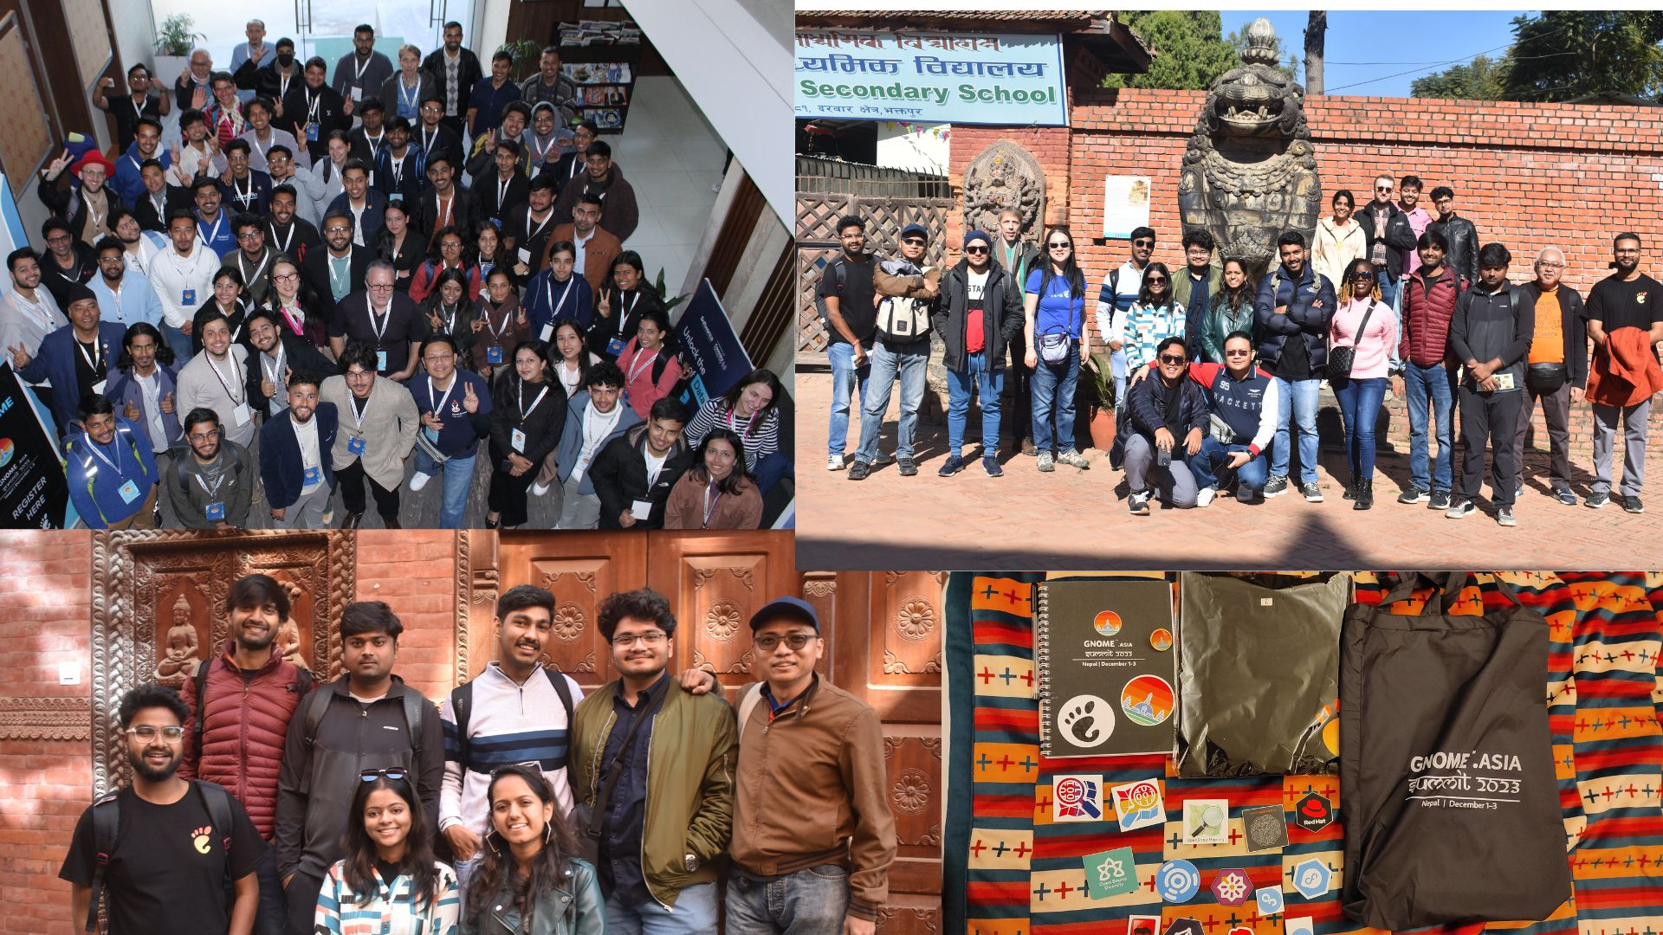

- Naman Kansal ( Batch: 2024-28) has been shortlisted provisionally by Prayas Management Committee (PMC) to avail NIDHI PRAYAS grant for Nidhi Prayas round 5 via TBI -KIET.
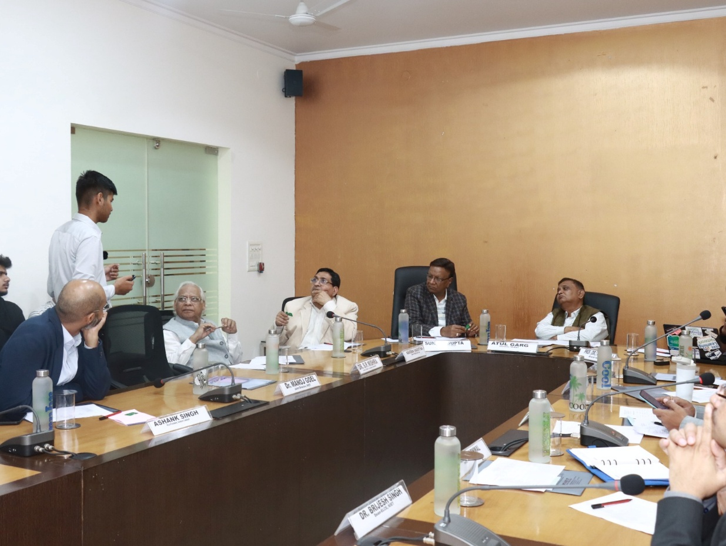
- Aditi Batra (Batch: 2020-24) is one the top 10 University Rank Holder and has secured 7th Rank in the University.
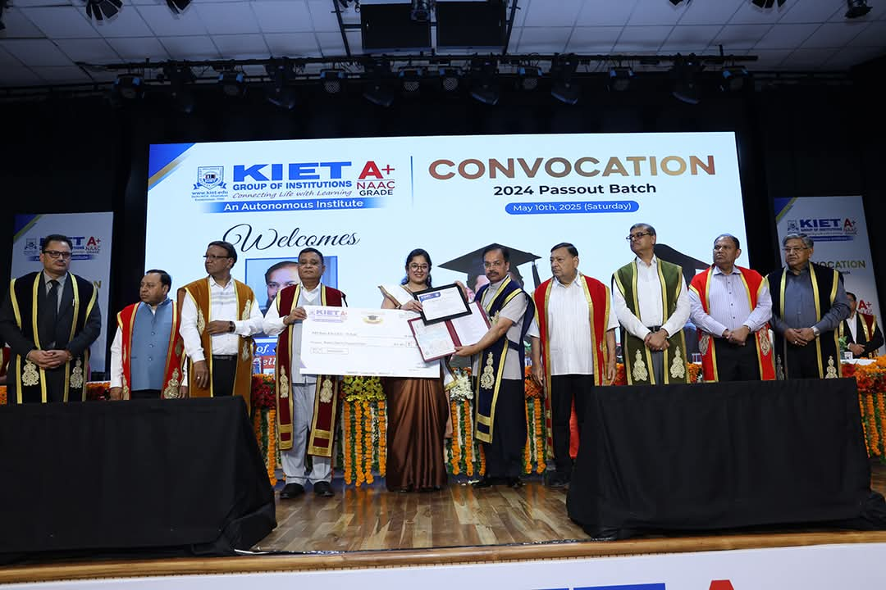

- Taniya Singh (Batch: 2020-24) is one the top 10 University Rank Holder and has secured 5th Rank in the University.
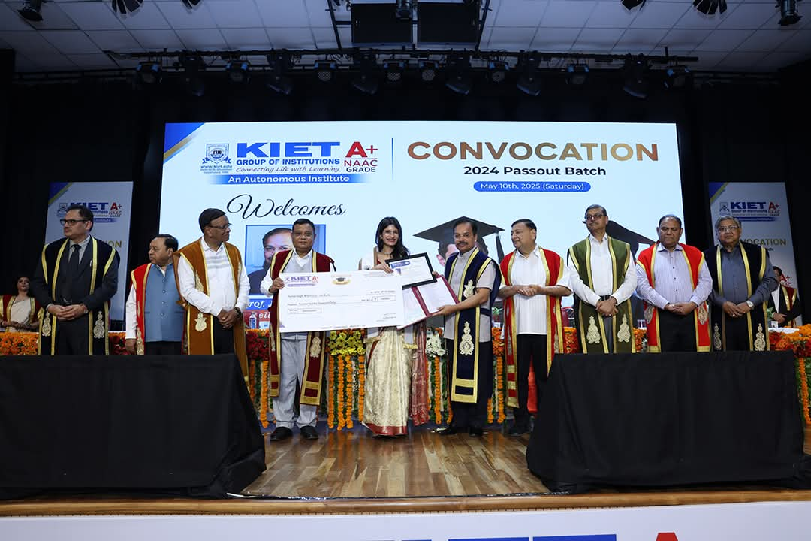
7. Our Student Vipin Chauhan (Batch : 2021-25) has been selected as Sub Lieutenant in Indian Navy.

